Hi <plan member name>,
It’s now easier for you to use both your Manulife group benefits and group retirement plans while on the go. We’re excited to bring you a new design that combines all the features of our existing apps into one.
Download ‘Manulife Mobile’ for Apple or Android today!
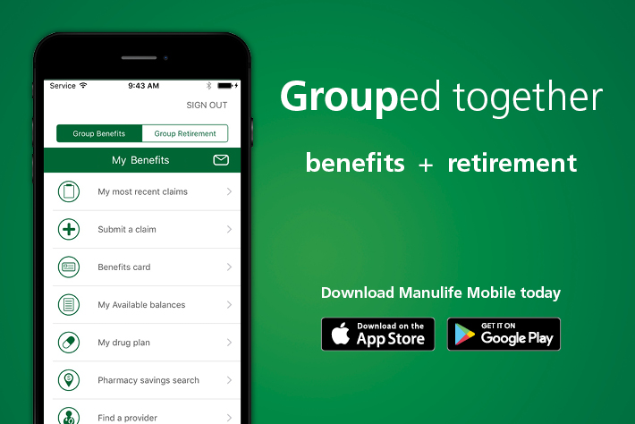
Discover more enhancements at your fingertips.

